
QUALITY ALERT

Customer: ChamClad Date: May 16, 2023
Die: 15750 Color: Any
Type of Complaint: ChamClad COMPAINT Customer NCR:

Description: ChamClad COMPAINT – The punch hole was OUT OF DIMENSION – the width up to 0.190”

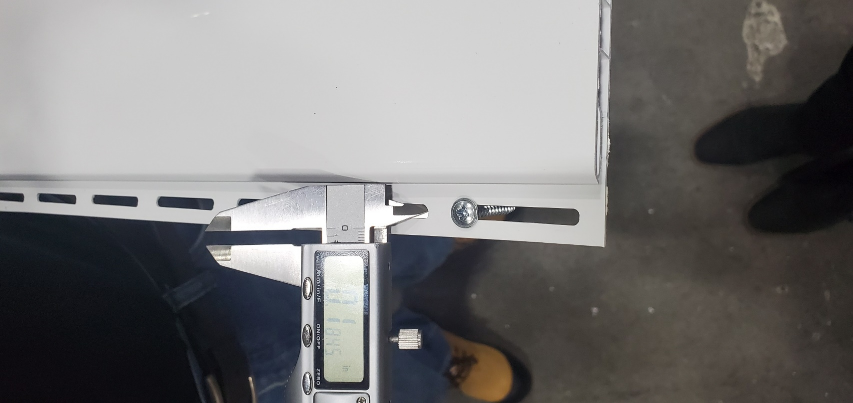

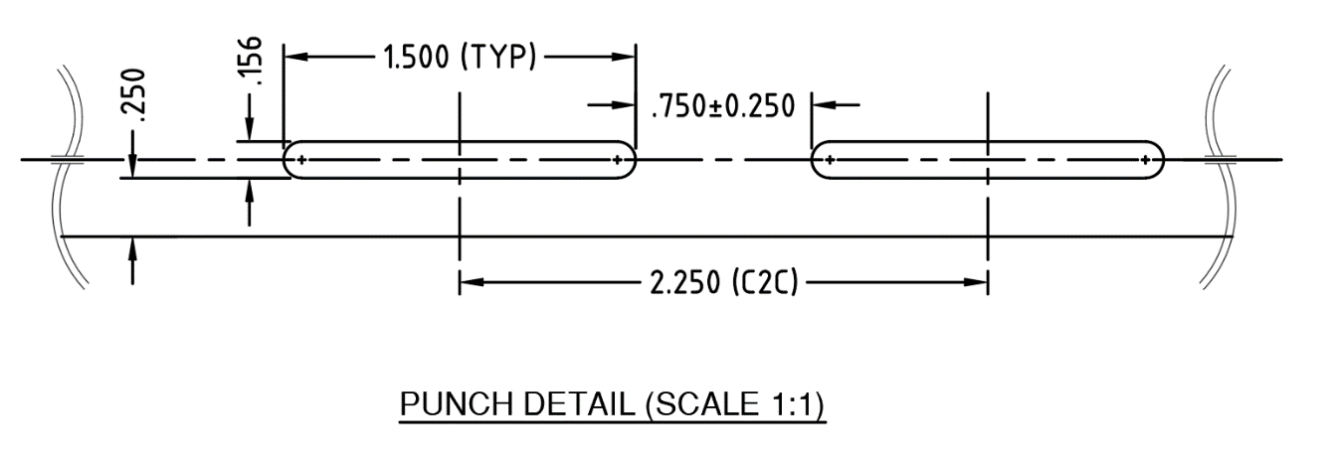

PLEASE CHECK CAREFULLY TO AVOID THIS ISSUE
BY SIGNING BELOW, YOU ACKNOWLEDGE THE PROBLEM ABOVE AND AGREE TO MONITOR THIS ISSUE IN FUTURE PRODUCTION RUNS.
DAY SHIFT |  | AFTERNOON SHIFT |  | NIGHT SHIFT
NAME | SIGNATURE | NAME | SIGNATURE | NAME | SIGNATURE

